Time | Concept | Explanation | Example
Lesson 01
17:57 | Anonymous Functions | - Function saved without name as variable  - Arrow Function | 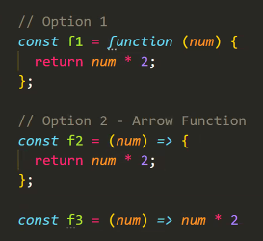
18:07 | Promises | Promise – is the JS special class for returning the response of asynchronous functions | 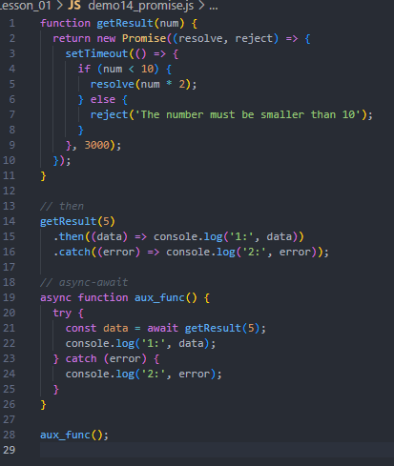
NODE.JS
- Create the folder for all package\project
- npm init OR npm init -y
  - OR Create package.json file into the folder -> all project information
- Create entrypoint -> index.js
18:51 | `Hello ${prop}` | Template leterals | 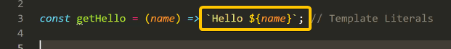
18:53 | Export functions from file | Module export | 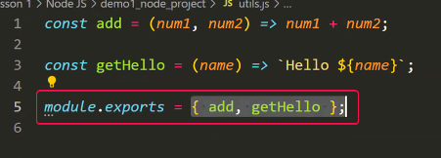
18:53 | Import functions to my js file | Import to module | 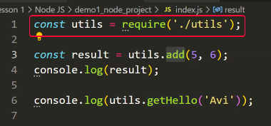
18:30 | Lab 02 Solution
 | Array.reduce() | The way for count the values from array  Like total of all numbers into array | 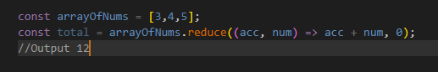
Install the json files library reader
npm I jsonfile
20:12 | JSON Files management | Import the library to the main file (file into you use the json file) | 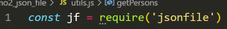
 |  | Use the library | 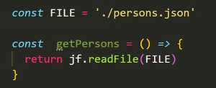  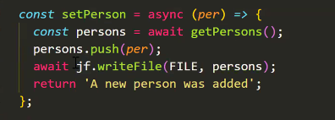
20:

